Usage of the Sharegate Automation script

# Introduction:

This script is used to automate the SharePoint migration from on-prem to online SharePoint sites. The script is tested for SharePoint 2013 on-prem to SPO.

# Pre-requisites:

You need to have Sharegate version installed to latest version 16.0.1.

# Steps:

Following steps are needed to work on the script

Step1: Copy the script to the server where the Sharegate tool is installed.

Step2: Open the script in powershell editor preferably Powershell ISE and change the following values

* $LogPath
* $ErrorLogFile
* $SitesInfo

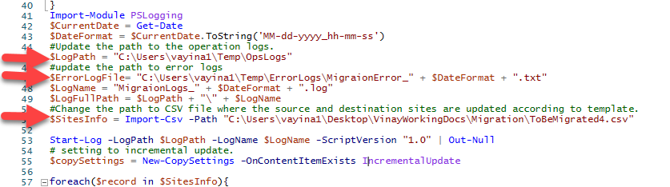

Step 3: Update the csv according to following format. You can update the CSV to more than one sites. Please note that do the migration in batch as the token life time for the migration is ranges from 24 hours to 2 days. The script is tested for 2 sites and can do upto 5 assuming the sites are of plain vanilla configuration.

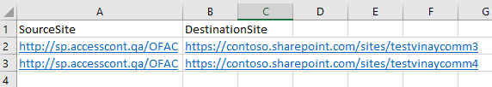

Step 4: Run the migration, on successful authentication and validation it will give the below error message.

The PS script validates the sites and checks for access

On successful authentication it will give start migration the content from source to destination.



Step 5: The progress of the migration task can be checked at Sharegate Migration tool, and in ‘Tasks’ tab.

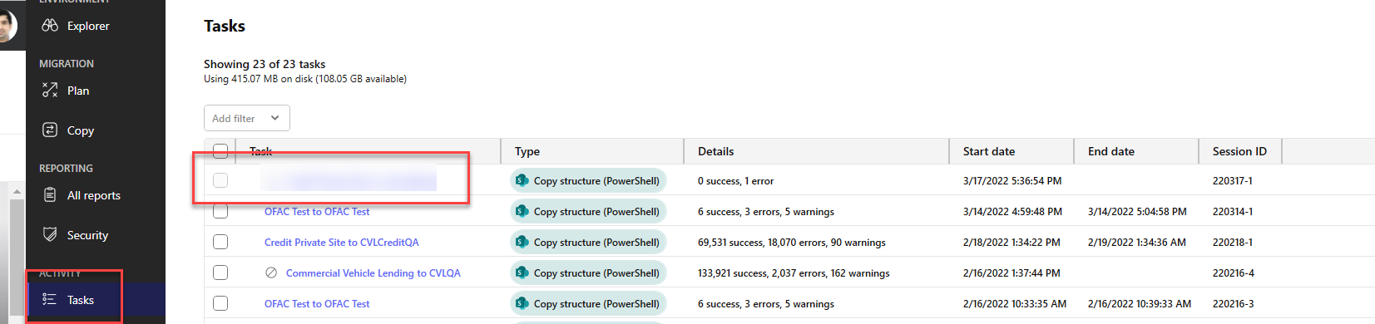

# Checking the logs:

* On error you can check them at logs at specified log location

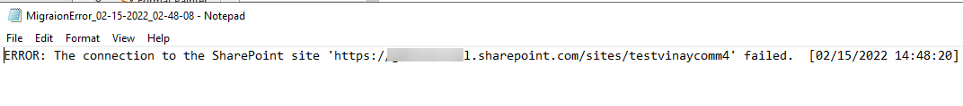

* Operation logs can be seen at specified log location.

